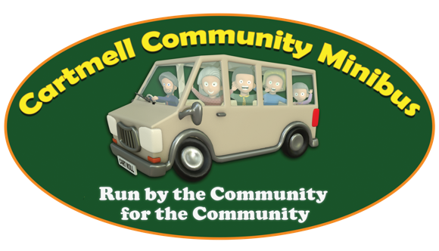
APPLICATION FOR REGISTRATION OF A COMMUNITY ORGANISATION

If this application form is accepted, the applicant community organisation will be entitled to the use of the minibus provided that the proposed driver is registered with and acceptable to Cartmell Community Minibus.

NAME OF ORGANISATION:
If registered with or affiliated to a National Body, please state name of association: -
Place of Meetings: -
Purpose of Organisation: -
Activities: -
Number of members:
PRINCIPAL OFFICERS’ NAMES AND ADDRESSES*: -
Chairperson: -
 |  |  |  |  |  |  |  | Tel
Email:
Treasurer: -
(address for invoice) |  |  |  |  |  |  |  | Tel
Email:

Signed | Date:
(Chairperson/Secretary)

NB Please remember to let us know if there are any changes to these contact details.
Please return to: - Jonathan Barstow cartmellminibus@gmail.com
Harcombe, The Hill, Little Somerford, Chippenham, SN15 5BQ
01666 822651

* Personal details of the officers/drivers nominated by the organisation requesting use of the minibus will be stored electronically in password protected files and/or on paper in a secure location. This data will be used primarily to enable communications that facilitate the vehicle’s hire and only put to other legitimate purposed necessary for the sound management of the CCMinibus in accordance with our Privacy Policy (available on request).

